## Department of information science and engineering

B.M.S College of Engineering

### P.O. Box No: 1908, Bull Temple Road, Bangalore – 560019



## 

## ‘Programming with c++’ project report on

1BM16IS062 | 1BM16IS064 | 1BM16IS071

Character Recognition

Aishwarya Naidu | Pooja Chadha | Tejaswini T N

# OUTLINE

1. Introduction……………………………….2
2. Problem Statement…………………….3
3. Concepts Used……………………………4
4. Tools Used…………………………………6
5. Design……………………………………….7
6. Screenshots………………………………9

# INTRODUCTION

In today’s world, there is growing demand for software system to recognize characters in computer system where information is scanned through paper documents. There is a huge demand in storing the information available in these papers documents into a computer storage disc and then later reusing this information. One simple way to store information available in these paper documents in to computer system is to first scan the documents and then store them as **images**. But it is difficult to reuse this information, read the individual contents and search content from these documents line-by-line and word-by-word.

The concept of storing the contents of paper documents in computer storage place and then reading and searching the content is called **document processing**. For this we need a **CHARACTER RECOGNITION SYSTEM**. It performs document image analysis which transforms documents in paper format to electronic format. For this process there are various techniques in the world. Among all those techniques we have chosen Optical Character Recognition as main fundamental technique to recognize characters.

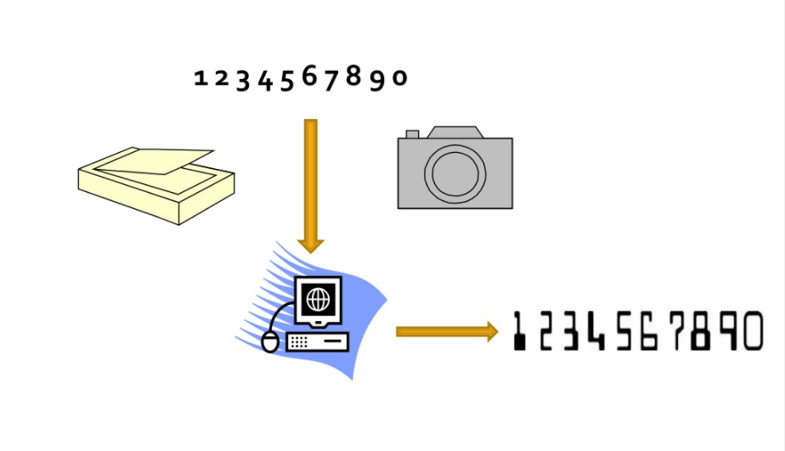

# PROBLEM STATEMENT

Humans are bound to make errors – some time or the other – especially while performing routine tasks like digitization or continuously. Many time we are unable to perceive certain digits due to various factors – motion, lack of digit clarity and illumination and so on. It is these problems which have primarily lead us to delve into character recognition.

Optical character recognition is a resourceful piece of software which involves the electronic conversion of scanned images of typewritten or printed text into machine-encoded or computer readable text while being accurate by reducing human error. It is heavily used in the industry.

It is a common method of digitizing printed texts. It has numerous application and uses such as editing, scanning, searching, comparison, compact storage and many more. OCR is a field of research in pattern recognition, artificial intelligence and computer vision.

## CONCEPTS USED

## Classes and Objects:

Classes are the most important feature of C++ that leads to Object Oriented Programming. Class is a user defined data type which holds its own data members and member functions which can be accessed and used by creating instances of the class called as objects. We have used three classes: ImagesAndChars in GenData.cpp and Image and ContourWithData in TrainAndTest.cpp. We have created object i which is an instance of the class ImagesAndChars to process and train.

## Constructors:

Constructor is a kind of member function that initializes an instance of a class. A constructor has the same name as the class and no return value. We have used constructors in class ImagesAndChars to initialize the valid characters allowed for training. We are only accepting uppercase alphabets and digits. Therefore, intValidChars is initialized to them.

ImagesAndChars()

{

intValidChars = { '0', '1', '2', '3', '4', '5', '6', '7', '8', '9', 'A', 'B', 'C', 'D', 'E', 'F', 'G', 'H', 'I', 'J','K', 'L', 'M', 'N', 'O', 'P', 'Q', 'R', 'S', 'T', 'U', 'V', 'W', 'X', 'Y', 'Z' };

}

## Static Variables:

By declaring a function member as static, you make it independent of any particular object of the class. A static member function can be called even if no objects of the class exist and the static functions are accessed using only the class name and the scope resolution operator ‘::’.

## Templates and Vectors:

Templates are a feature of C++ programming language that allows function and classes to operate with generic types. This allows a function or class to work on many different data types without being rewritten for each one.

C++ has a vector class within the std namespace. A vector is similar to an array, in a sense where a series of elements are stored within same variable name. Unlike arrays, vectors are dynamically sized.

## Inheritance:

The class which inherits the properties of another class is called derived class and the class whose properties are inherited is called base class. When a single class is derived from a single base class, it is called Single Inheritance.

Fig: Single inheritance used in testing process

# TOOLS USED

Visual Studio 2017:

We used this as the main Integrated Development Environment (IDE) to compile, debug and run the code.

OpenCV:

We used this library to process the images and for implementing the functions needed for the **k-nearest algorithm.**

Adobe Photoshop:

Photoshop is an image editing software. We have used this to create our training image and testing images.

DESIGN

There are two processes involved to recognize the characters in any givem image: training or generating the dataset and then testing or recognition. These processes depend on the K-Nearest Neighbrs (KNN) algorithm. K-Nearest Neighbors is a simple algorithm that stores all available cases and classifies new cases based on a similarity measure.

In the process of generating data we have created a class called ImagesAndChars. In this class we have created many data members of the type Mat which is the basic image container in OpenCV, member functions for reading the training images, finding the contours and various other conversions.

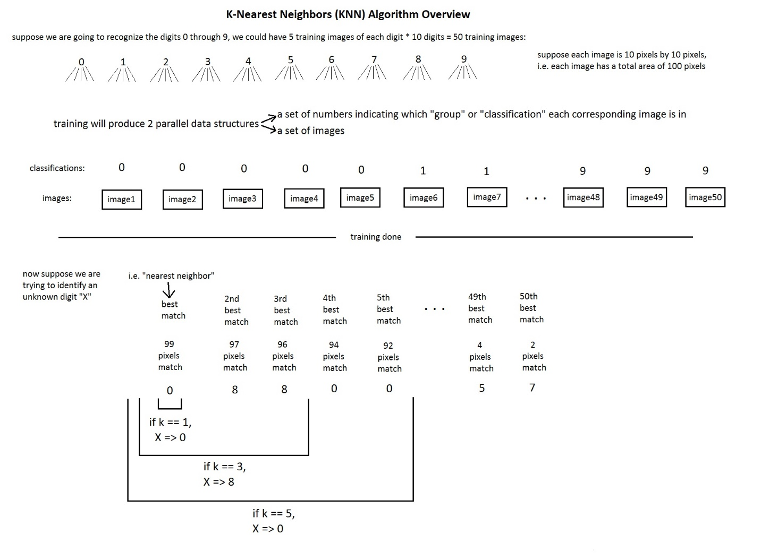

The contructor is used to initialize the valid characters which are acceptable i.e., uppercase alphabets and digits. After the training process the images and classifications are saved into ‘images.xml’ and ‘classifications.xml’ files using member functions saveClassification() and saveImages().

In the testing process we created two classes namely: Image and ContourWithData. The class ContourWithData inherits from the class Image publicly. The class Image again has data members of type Mat to store basic images. It also has member functions to read classifications, images and the test image which we need to recognize. In we have static bool sortByBoundingRectXPosition() function to determine new contours each time it is called. For recognition, we just open the test image, implement the algorithm on the valid contours and print out the final string to the console.

## SCREENSHOTS

**Training (GenData.cpp):**

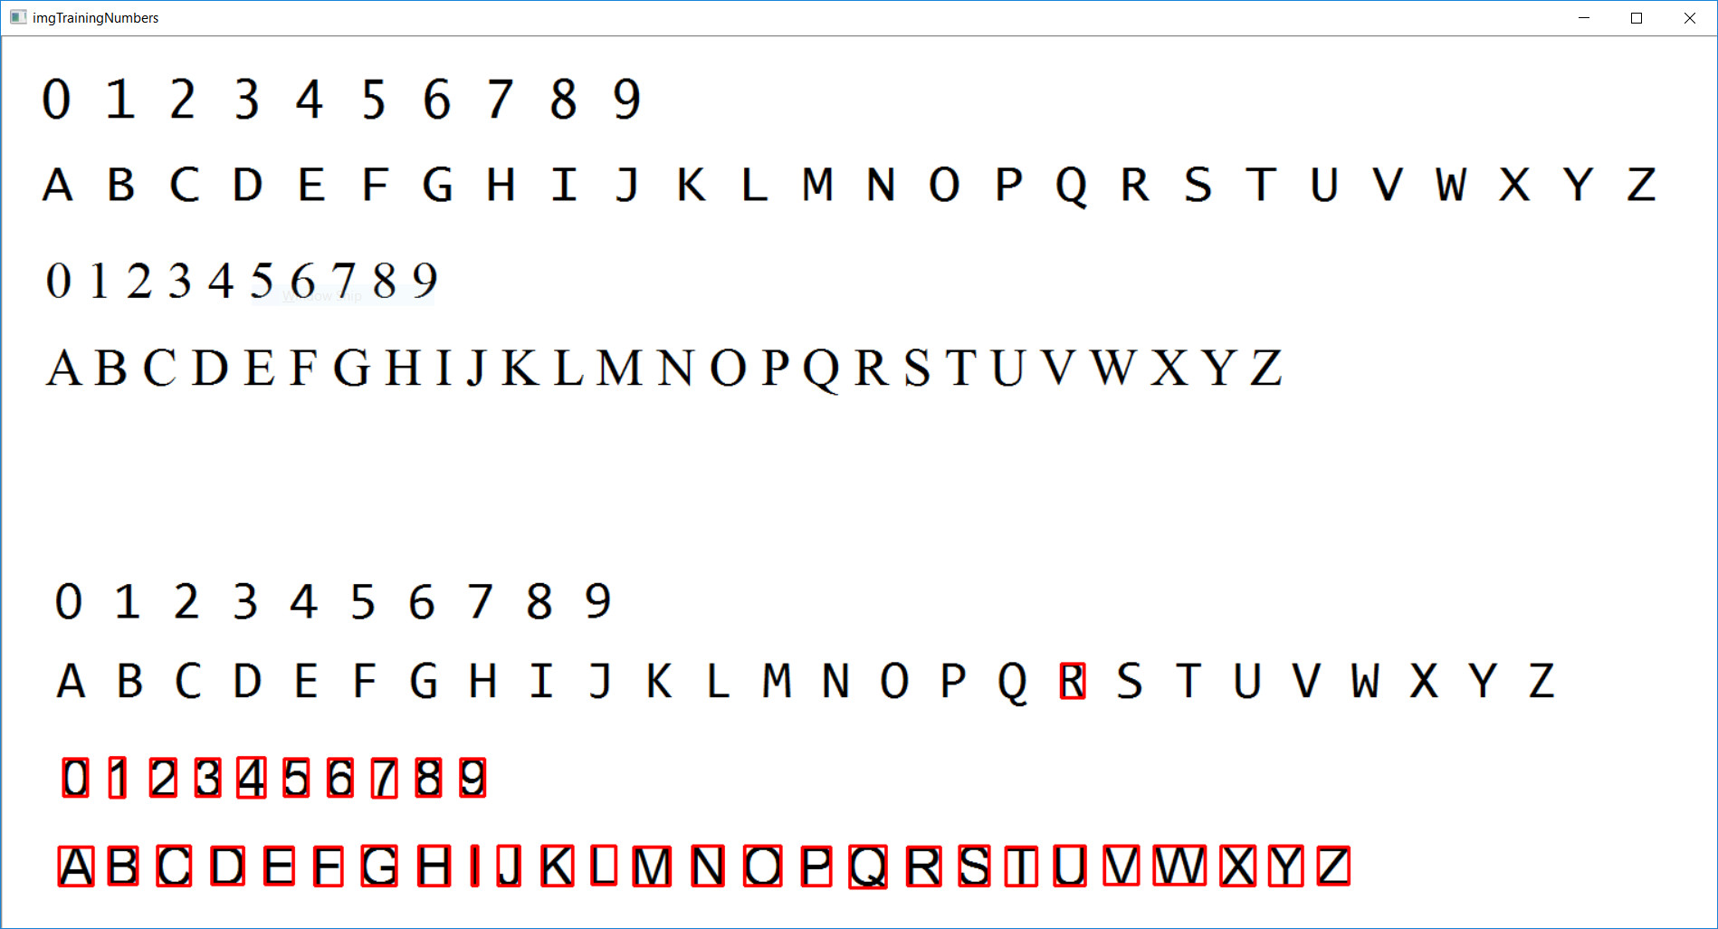

**Recognition (Test AndTrain.cpp):**